**Public and Private VPC test**

Create a VPC

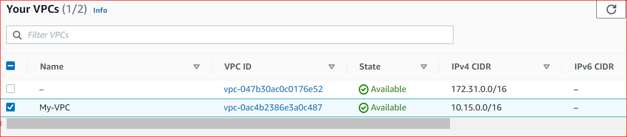

Create two subnets one for public and another one for private.

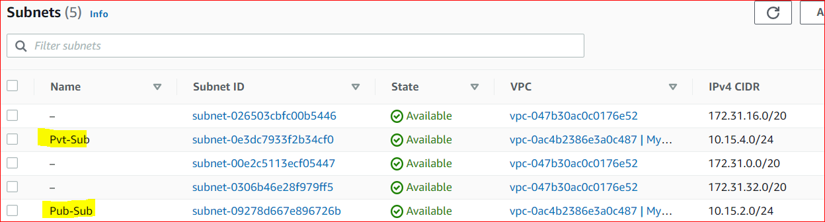

Create IGW.

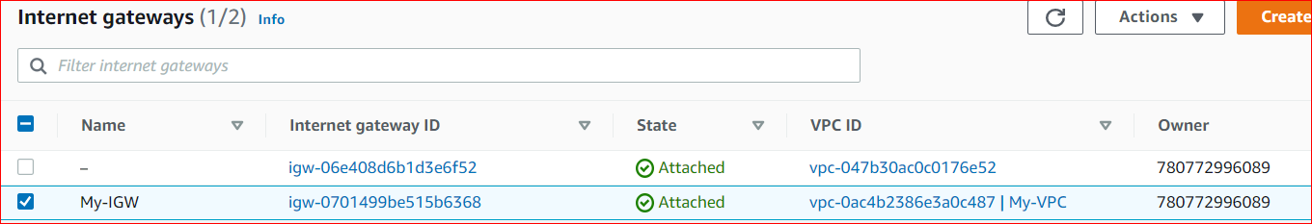

Create two route table and add the IGW in public RT. Add the public subnet in subnet association

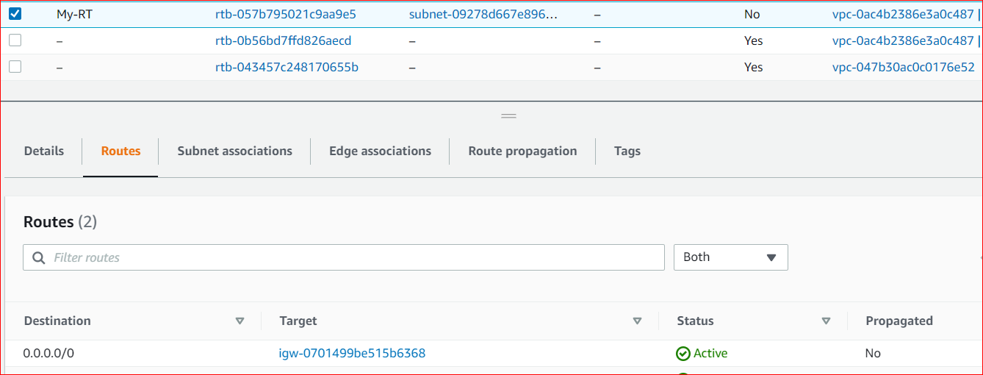

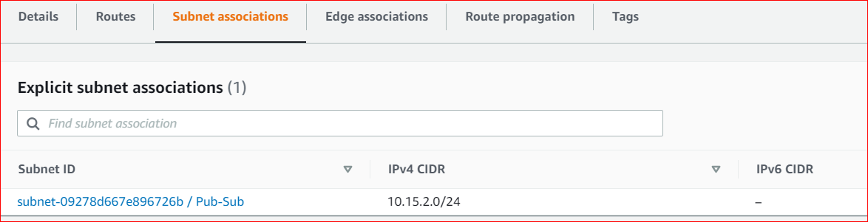

In another private RT no need to add IGW only add the public subnet in the subnet association.

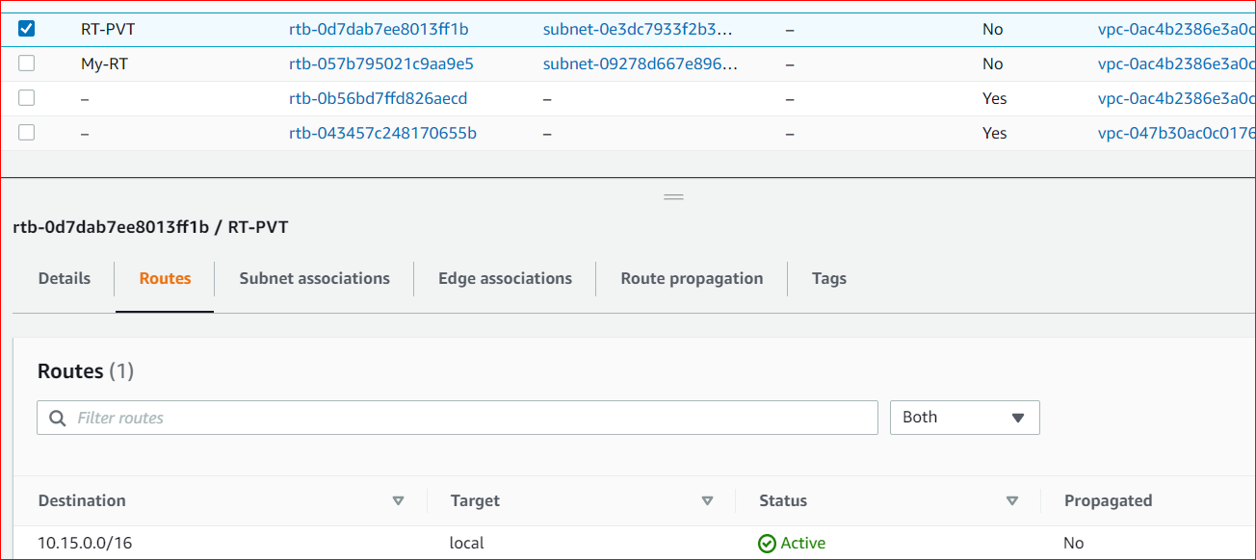

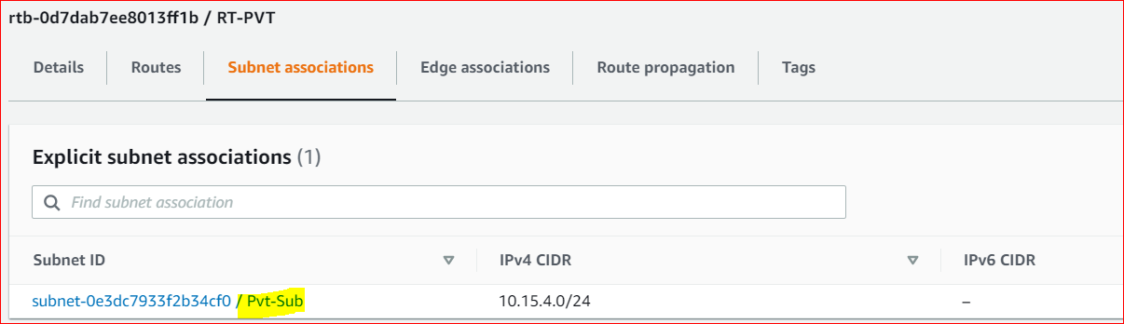

Create one instance using your own vpc with public subnet.

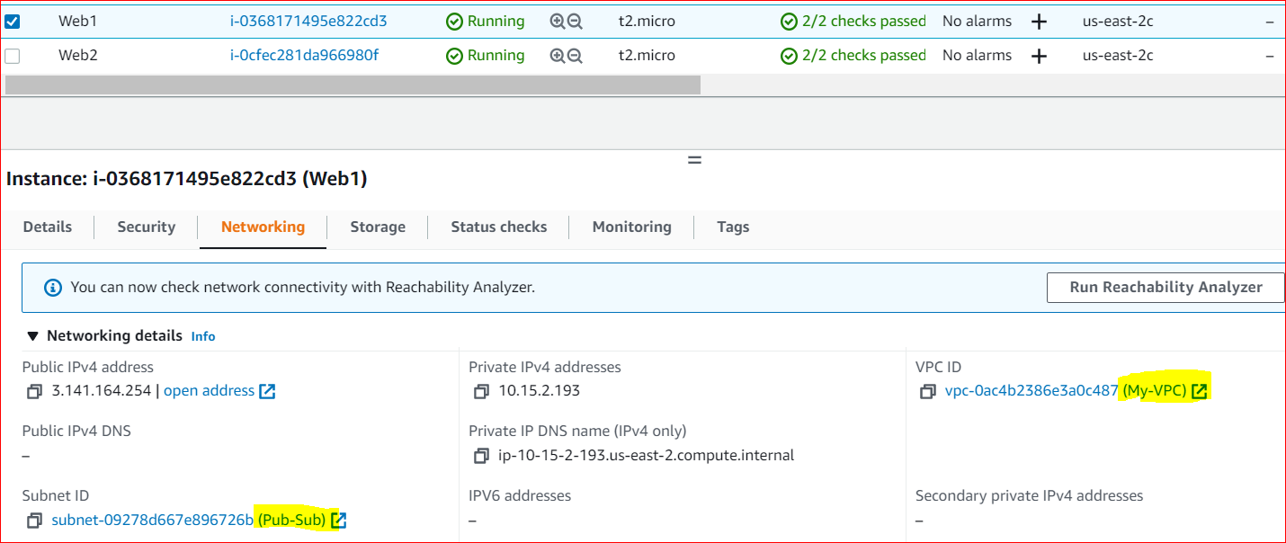

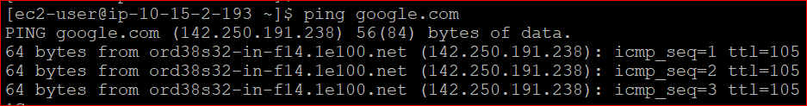



Launch another instance with private subnet.

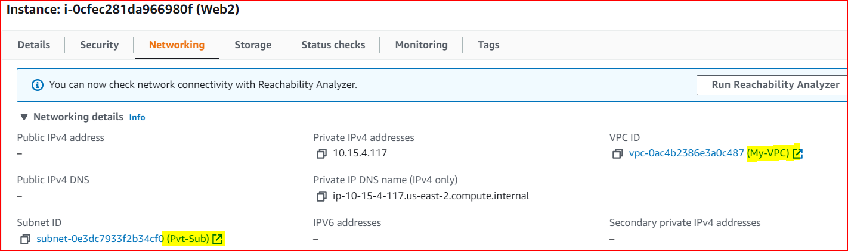

Copy the pem key into public instance using Winscp and try to login private instance.

